MODIFY OR RECTIFY PRIMARY & SECONDARY EMAIL ADDRESS OF EXISTING PARTNER/CLIENT

STEP 1:

* Go to sales->customer-> advance search-> search criteria : "email" "contains" ";"

* Hit "apply" button

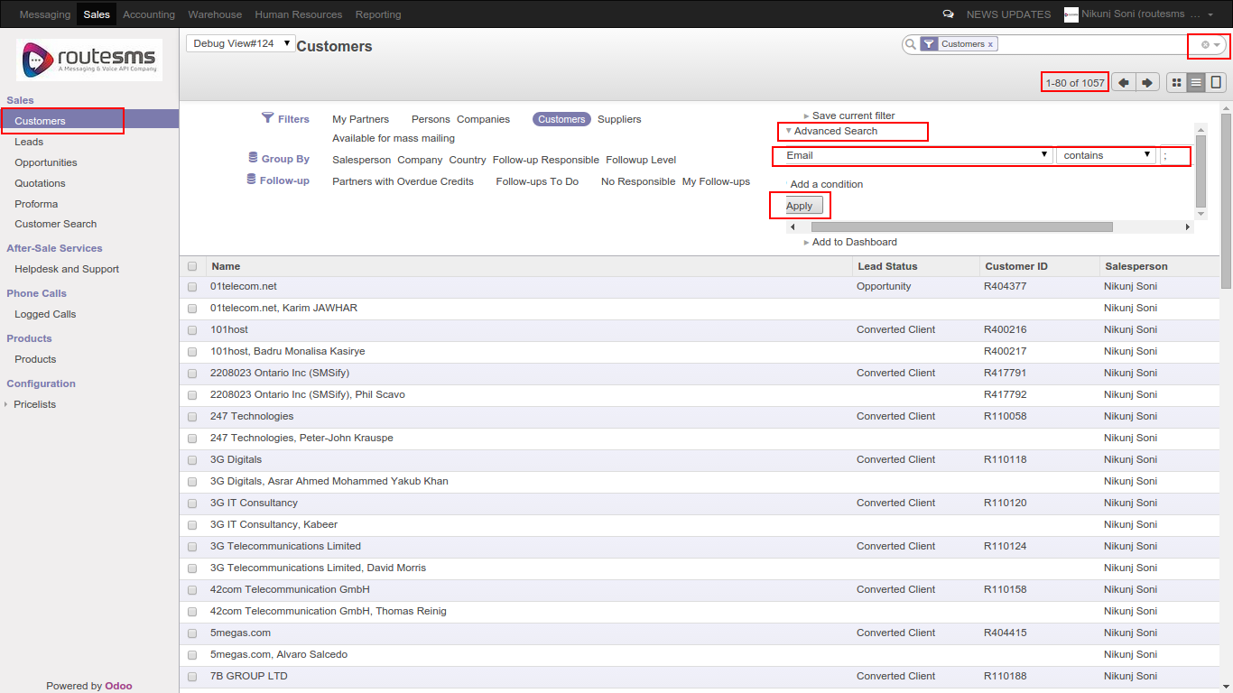

STEP 2:

* Results contains records which contains invalid email addresses

* Open partner record and modify contact information

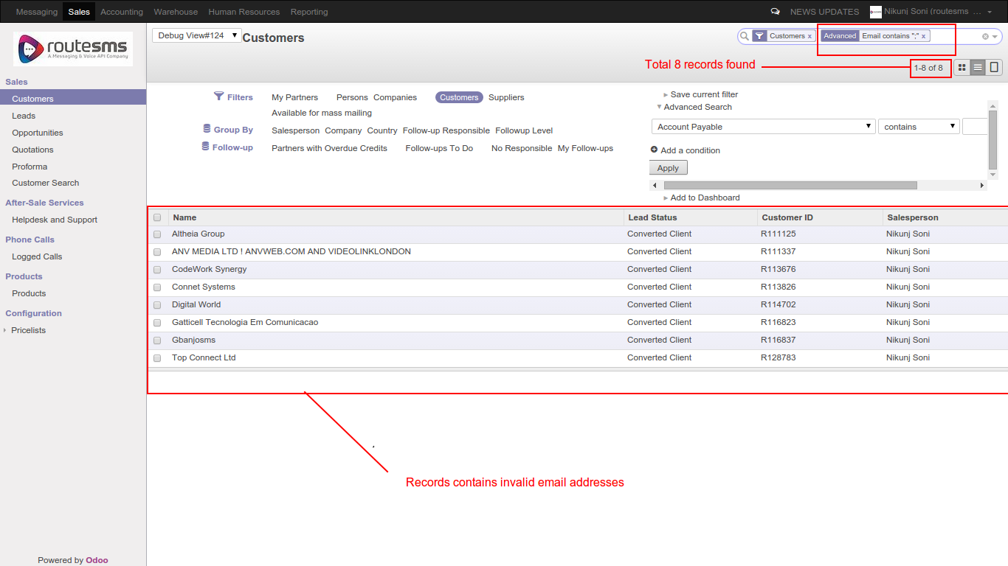

STEP 3:

* Check contact details of partner.

* Click “edit” button to modify the contact details

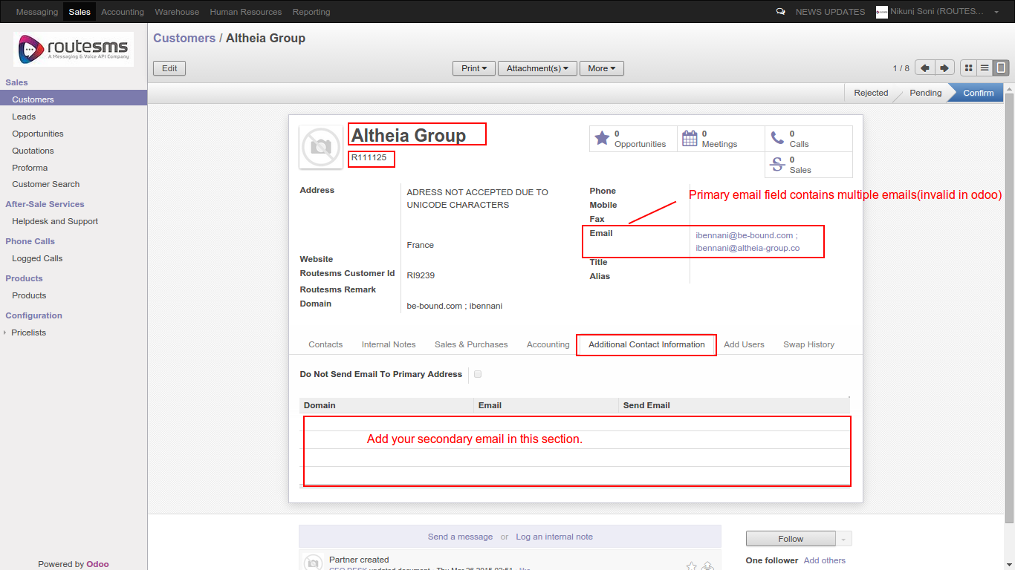

STEP 4:

* Modify primary email address

* Insert secondary email address

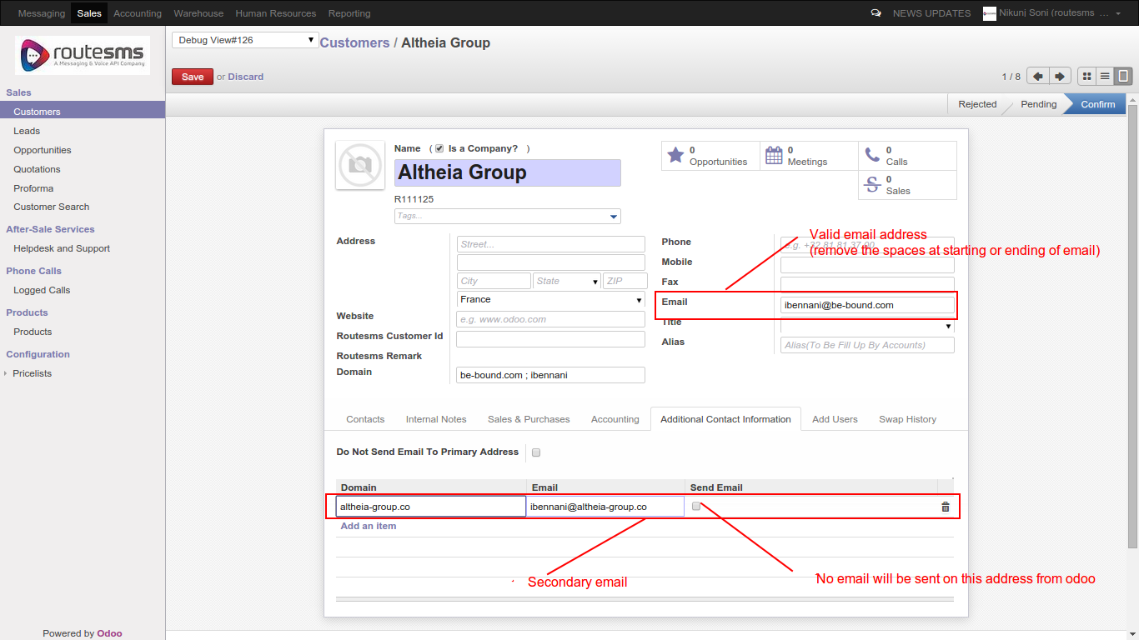

THANK YOU

